Superstore Sales Data Analysis
____________________________________________________________________________
____________________________________________________________________________

Project Overview
Project Name: Superstore Sales Data Analysis using MySQL
Tool: MySQL Workbench 8.0
Dataset: Sample Superstore CSV (9,994 rows)
Language: SQL (Structured Query Language)
Goal:
To analyze sales, profit, customer, and product performance of a retail superstore using SQL queries and derive meaningful business insights from the data.

Project Introduction
The Superstore Sales Data Analysis is a structured and comprehensive data analysis project developed using MySQL and MySQL Workbench 8.0. The primary objective of this project is to extract meaningful and actionable business insights from a retail superstore's transactional dataset using Structured Query Language (SQL).
The dataset contains detailed information about customer orders, product categories, shipping modes, regional distribution, and financial metrics across different regions of the United States. The data spans multiple years of transactions and covers a wide range of products across three major categories — Furniture, Office Supplies, and Technology.
By applying SQL queries ranging from basic data retrieval to advanced analytical functions, this project demonstrates the real-world power of data-driven decision making in a retail business context. The project follows a complete data analysis lifecycle — from database creation and data import to validation, querying, and business insight generation.

Objectives of the Project
The key objectives of this project are as follows:
- To create and manage a structured MySQL database using MySQL Workbench 8.0
- To successfully import and load a large-scale retail CSV dataset into MySQL using the LOAD DATA INFILE command
- To perform structured analysis on sales, profit, customers, and products using SQL queries
- To identify top-performing and underperforming categories, regions, products, and customers
- To calculate key performance indicators (KPIs) such as total revenue, profit margin, average order value, and order volume
- To apply core and advanced SQL concepts including aggregation, filtering, date functions, window functions, and subqueries
- To resolve real-world database errors encountered during the import process and document their solutions
- To present all findings and project details in a clear, organized, and professional format suitable for business reporting and academic documentation

Dataset Description
The dataset used in this project is the Sample Superstore CSV file, which is a widely recognized and extensively used retail dataset for data analysis and business intelligence practice. It represents transactional sales data from a fictional retail superstore operating across the United States.
The dataset contains 9,994 rows and 21 columns, covering multiple years of customer orders. Each row represents a single product ordered within a transaction and includes complete details about the order, customer, product, shipping, and financials.
The 21 columns are organized into the following logical groups:
Identifiers: Row ID, Order ID, Customer ID, Product ID — used to uniquely identify each record, order, customer, and product.
Date Information: Order Date, Ship Date — used to analyze trends over time, calculate shipping duration, and perform monthly and yearly analysis.
Customer Information: Customer Name, Segment — used to identify and classify customers into Consumer, Corporate, and Home Office segments.
Geographic Details: Country, City, State, Postal Code, Region — used to perform location-based sales and profit analysis across different parts of the United States.

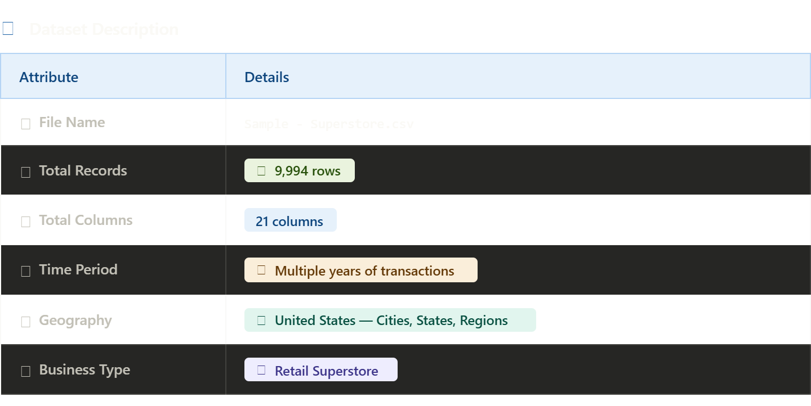.
Product Details: Category, Sub-Category, Product Name — used to analyze performance across Furniture, Office Supplies, and Technology categories and their sub-divisions.
Financial Metrics: Sales, Quantity, Discount, Profit — the core numerical columns used for all business calculations including revenue, profit margin, and discount impact analysis.

Project Workflow
The project was executed in a step-by-step structured workflow to ensure data accuracy and meaningful analysis at every phase.
Step 1 — Database Setup: A dedicated MySQL database named superstore_db was created in MySQL Workbench 8.0. This served as the working environment for all table creation, data import, and query operations throughout the project.
Step 2 — Table Creation: A table named superstore was designed with 21 columns, each assigned an appropriate data type. Row_ID was set as the Primary Key. Text columns used VARCHAR, date columns used DATE, and financial columns used DECIMAL(10,4) to preserve full decimal precision.
Step 3 — Data Import: The CSV file was imported using the LOAD DATA INFILE command. The file was moved to the MySQL Uploads folder to comply with server restrictions. CHARACTER SET latin1 was added to handle special characters, and STR_TO_DATE() was used to convert date strings into MySQL DATE format.
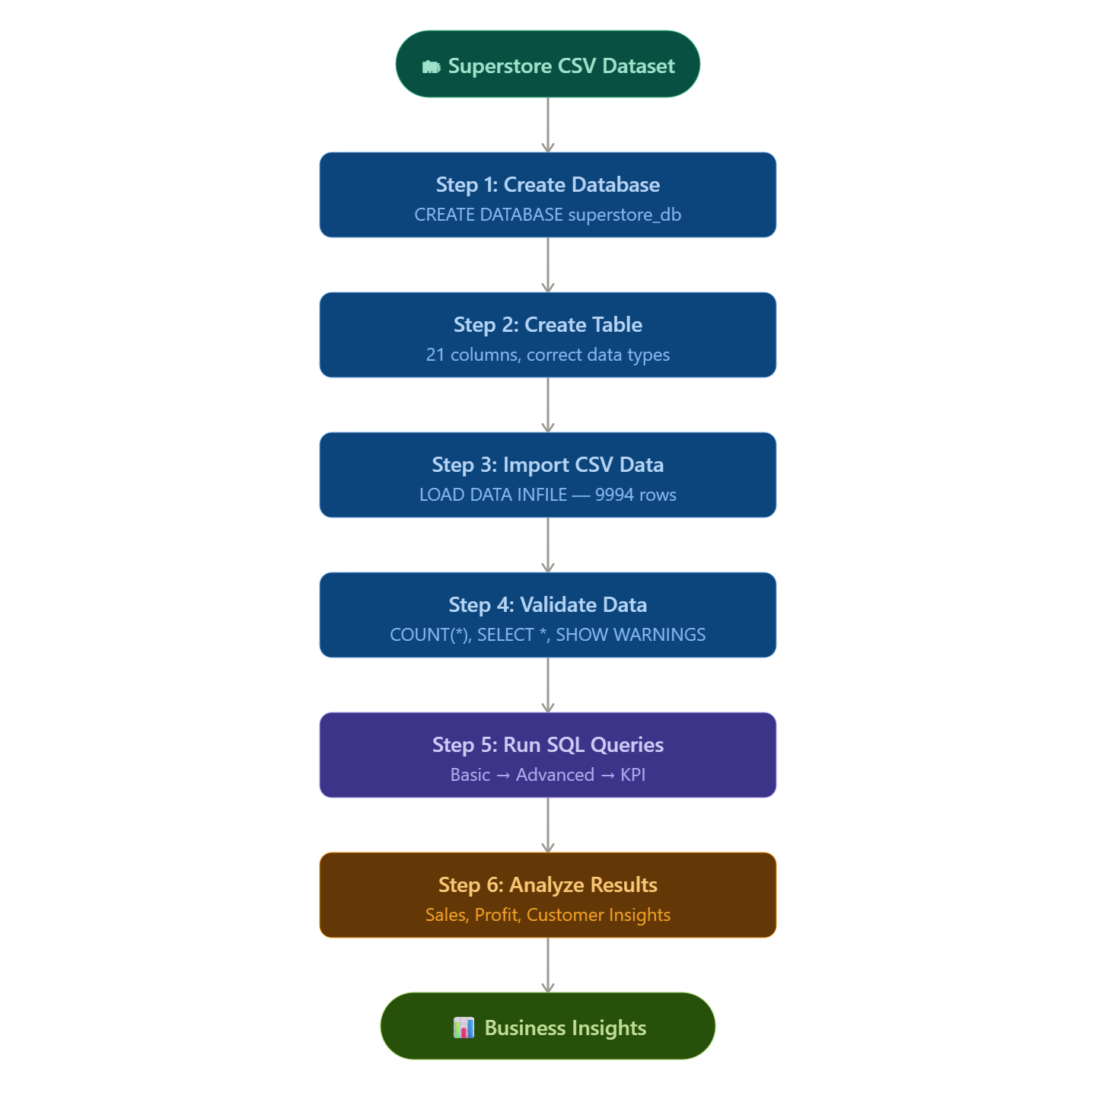
Step 4 — Error Resolution: Four major errors were encountered and resolved during the import process — Error 1290 (secure_file_priv), Error 1300 (encoding issue), Error 1265 (decimal truncation), and Error 1062 (duplicate primary key). Each error was analyzed and fixed systematically.
Step 5 — Data Validation: After successful import, data accuracy was confirmed using SELECT COUNT(*), SELECT * LIMIT 10, and SHOW WARNINGS to ensure all 9,994 rows were correctly loaded with proper formatting.
Step 6 — SQL Querying: A total of 29+ SQL queries were written and executed across five progressive levels — from basic SELECT statements to advanced window functions — to extract comprehensive business insights.
Step 7 — Result Analysis: Query results were interpreted to identify top-performing categories, regions, products, and customers, and to detect loss-making areas impacted by heavy discounts.
Step 8 — Documentation: All project phases, errors, queries, and findings were compiled into a structured documentation report with flowcharts, tables, and written descriptions.

Data Import Pipeline
The data import process followed a specific pipeline to ensure the CSV data was correctly loaded into MySQL without errors.
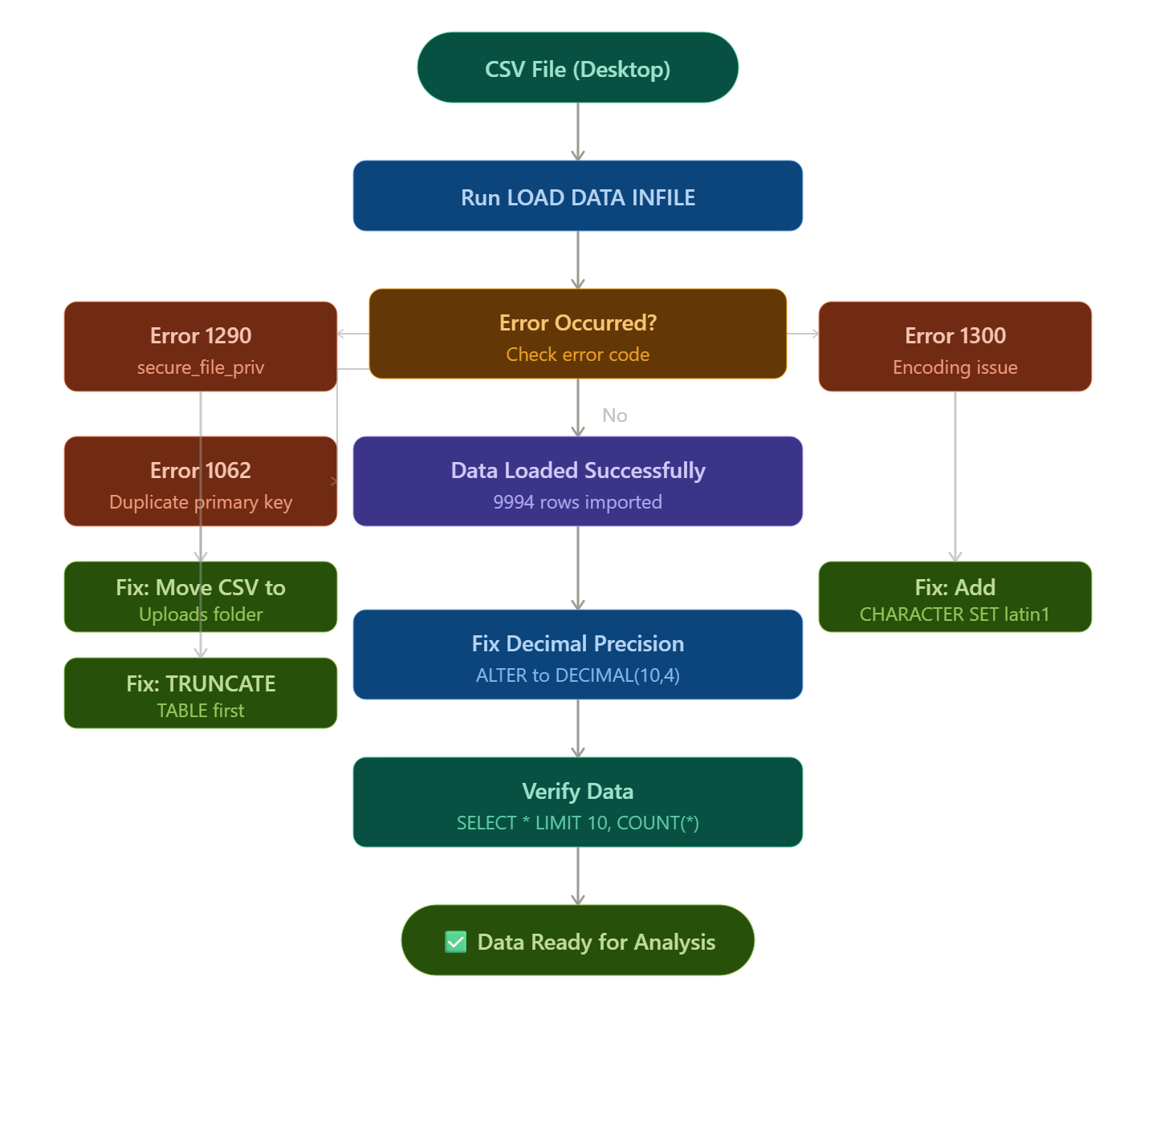The CSV file was first prepared on the local system and moved from the Desktop to the MySQL-permitted Uploads folder at C:/ProgramData/MySQL/MySQL Server 8.0/Uploads/. The LOAD DATA INFILE command was then executed with the correct file path, field delimiter set to comma, text enclosed in double quotes, and line terminator set to \r\n for Windows-format CSV files.
The CHARACTER SET latin1 option was included to handle special characters found in product names. Date columns were converted from their original string format to MySQL DATE format using STR_TO_DATE() with the %m/%d/%Y pattern. After resolving all errors, all 9,994 rows were successfully imported in a single clean execution with no remaining warnings.

SQL Analysis Structure
The SQL analysis was organized into five clearly defined levels to progressively build complexity and depth of insight.

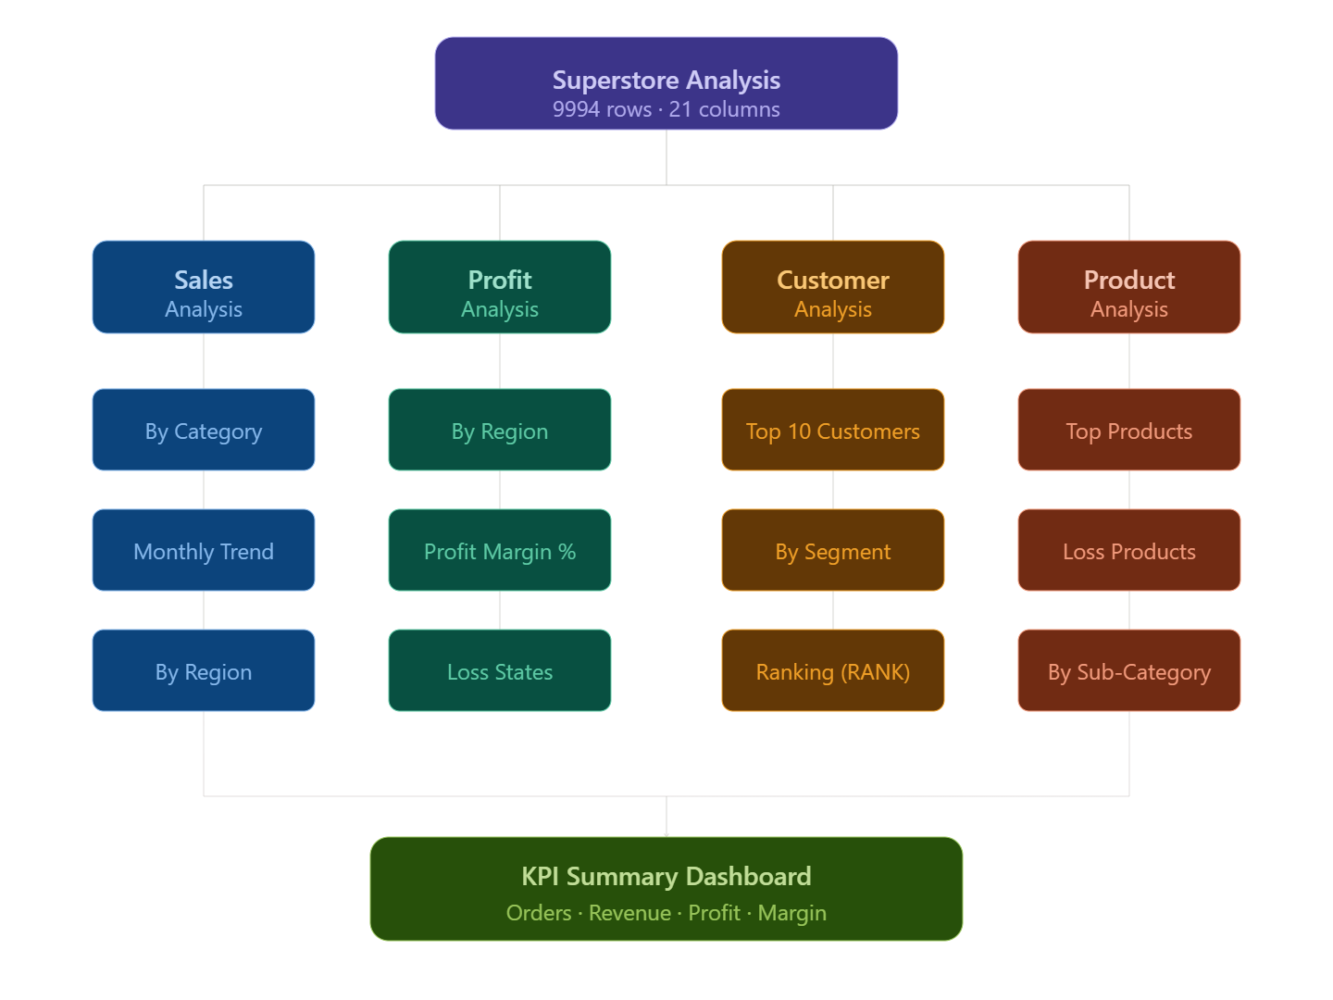
Level 1 — Basic Queries covered fundamental operations such as SELECT, WHERE, ORDER BY, LIMIT, and DISTINCT to explore and filter the dataset by state, year, category, and discount range.
Level 2 — Aggregation Queries introduced GROUP BY combined with SUM(), AVG(), COUNT(), and ROUND() to calculate total sales, total profit, and average discount across categories, regions, sub-categories, and segments.
Level 3 — Business Analysis Queries answered practical business questions such as identifying the top 10 profitable products, top 10 loss-making products, monthly and yearly sales trends, profit margin by category, and the relationship between discount and profit.
Level 4 — Advanced Queries applied window functions including RANK(), ROW_NUMBER(), and SUM() OVER() with PARTITION BY to produce customer profit rankings, running sales totals, and segment-wise yearly comparisons.
Level 5 — KPI Dashboard Query consolidated all key business metrics into a single comprehensive query delivering total orders, total customers, total products, total revenue, total profit, average order value, and overall profit margin percentage in one result set.

Tools and Technologies Used
MySQL Workbench 8.0 was the primary tool used throughout the project for database creation, table design, data import, and query execution.
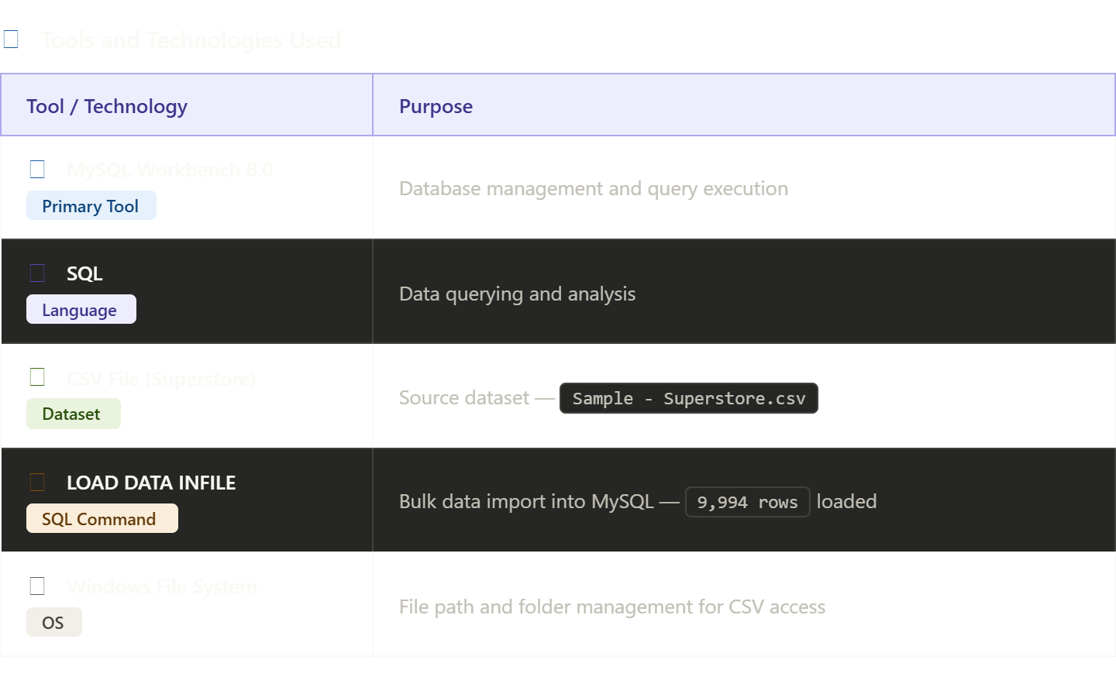
MySQL Workbench 8.0 provided a visual and command-line interface for managing all database operations.
SQL (Structured Query Language) was the core language used for all data operations including table creation, data import, validation, and multi-level analysis queries.
Sample Superstore CSV served as the source dataset, providing 9,994 rows of retail transaction data across 21 columns representing orders, customers, products, and financials.
LOAD DATA INFILE was the SQL command used to perform bulk import of the CSV data into the MySQL table efficiently in a single operation.
Windows File System was used for managing the CSV file location, moving it to the MySQL-permitted Uploads directory, and handling file path configurations required for the import process.

